1ST CHECKPOINT
1st Dataset
- Dataset name and source – Marvel Universe Social Networks which I found from Kaggle
- Course topic alignment – Graph mining and Centrality measures
- Potential beyond-course techniques – link predictions
- Dataset size and structure – Number of nodes (heroes): 6426 and
Number of edges (hero–hero connections): 167219
- Data types – Categorical edge relationships
- Target variable(s), None
- Licensing or usage constraints – CC License

2nd Dataset
- Dataset name and source – Online retail dataset from UCI
- Course topic alignment – Frequent Itemsets Association Rule Mining
- Potential beyond-course techniques – ANOVA
- Dataset size and structure –around 500k rows with 25k unique transactions
- Data types – InvoiceNo, StockCode, Description, Quantity, CustomerID
- Target variable(s), None
- Licensing or usage constraints – (CC BY 4.0) license.

3rd Dataset
Dataset name and source – Spotify Tracks Dataset (public dataset from Kaggle derived from Spotify Web API)
Course topic alignment – Clustering (K-means), Similarity analysis
Potential beyond-course techniques Autoencoder-based feature compression,
Dataset size and structure – 170,653 rows (tracks).
Data types – Numerical features (danceability, energy, valence, tempo, loudness, acousticness, instrumentalness, liveness, speechiness, duration_ms, popularity, year), Categorical/text (artists, name, id, release_date), Binary (explicit, mode)
Target variable(s) – None
Licensing or usage constraints – Public dataset distributed via Kaggle

 | Marvel Network | Online retail | Spotify
Supported Data Mining Tasks | Centrality and pagerank  Beyond: Link predictions and Graph NN | Frequent item sets and association rules  Beyond: Anova | Clustering  Beyond: Autoencoder-based feature compression
Data Quality Issues | Low edge to node ratio  Graph sparsity | 135,080 missing CustomerID values  10,624 negative Quantity values | No missing data
Algorithmic Feasibility | 25k unique transaction so apriori feasible | Manageable for pagerank | manageable
Bias Considerations | Biased towards more popular heroes | Only from the UK
Ethical Considerations | No ethical issues as fictional superheroes | No user data but behavioral trends about people. | No personal user data

C) I chose the marvel dataset as I am invested in marvel and having a chance to do a project on an interest of mine sounds exciting. Moreover, it supports the graph mining techniques that we learned about as it feels like a social superhero network.
Trade-offs:
no node features and it is a fictional topic so not applicable to real world.

D)
===== BASIC NETWORK STATS =====
Number of nodes: 6426
Number of edges: 167219
Density: 0.00810031232553549
Connected components: 4
Average degree: 52.044506691565516
Maximum degree: 1908

===== TOP 10 HEROES BY DEGREE =====
CAPTAIN AMERICA : 1908
SPIDER-MAN/PETER PAR : 1737
IRON MAN/TONY STARK : 1522
THING/BENJAMIN J. GR : 1416
MR. FANTASTIC/REED R : 1379
WOLVERINE/LOGAN : 1371
HUMAN TORCH/JOHNNY S : 1361
SCARLET WITCH/WANDA : 1325
THOR/DR. DONALD BLAK : 1289
BEAST/HENRY &HANK& P : 1267

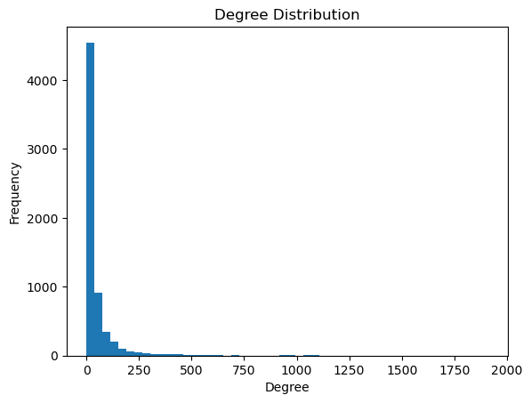

(E) Initial Insights and Direction – Ex:
Observation: the average degree is 53 while the maximum degree is 1908, which explains the difference in popularity and dominance of a small group of heroes for example, Spiderman and Captain America, while Pyro from the X-men wouldn’t be as popular or have high connectivity.
Hypothesis: PAGERANK AND CENTRALITY MEASURES WILL PROBABLY BIAS TOWARDS THESE POPULAR SUPERHEROS
Potential RQs:
- Would it be possible to discover a superhero team from our network? For example, identifying the Avengers just from how specific heroes appear together.
- Would applying link predictions would it be possible to predict a future collab between 2 heroes or no?

